

|  |
| --- |
| CS 1103 - FR02B  Lab 7 |
| By Ngoc Phuong Anh Nguyen - 3712361  March 2021 |

# **Exercise:**

## Add a scholarship column of type INT and default value of 0 to the Student table:

ALTER TABLE Students ADD scholarship INT;

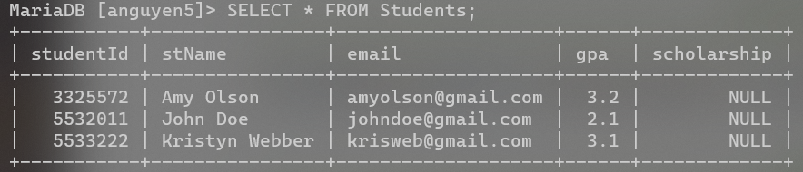

Figure : Students Table after adding a scholarship table.

## Write a stored procedure called AcceptStudent:

CREATE PROCEDURE AcceptStudent

(

name VARCHAR(50),

email VARCHAR(50),

average FLOAT

)

BEGIN

DECLARE scholarship INT;

IF average<=100 AND average>90 THEN

SET scholarship = 1500;

ELSEIF average <=90 AND average >85 THEN

SET scholarship = 1000;

ELSEIF average < 85 AND average>=0 THEN

SET scholarship = 0;

ELSE

SIGNAL SQLSTATE '45000'

SET MESSAGE_TEXT = 'The mark is out of range';

END IF;

INSERT INTO Students(stName, email, scholarship)

VALUE(name, email, scholarship);

END$$

## Also create script(s) to test the procedure

### 3 valid test cases

CALL AcceptStudent('Kevin Smith','kevinsmith@gmail.com',95);

CALL AcceptStudent('Eddy Jones','eddyjones@gmail.com',80);

CALL AcceptStudent('Eric Thomas','ericthomas@gmail.com',91);

### 1 test case with high school average out of range

CALL AcceptStudent('Envy Walker','envywalker@gmail.com',101);

### the resulting table

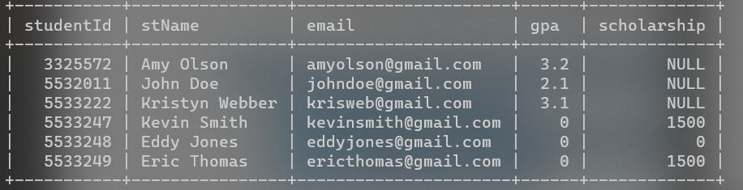

Figure : The result table after input test scripts.